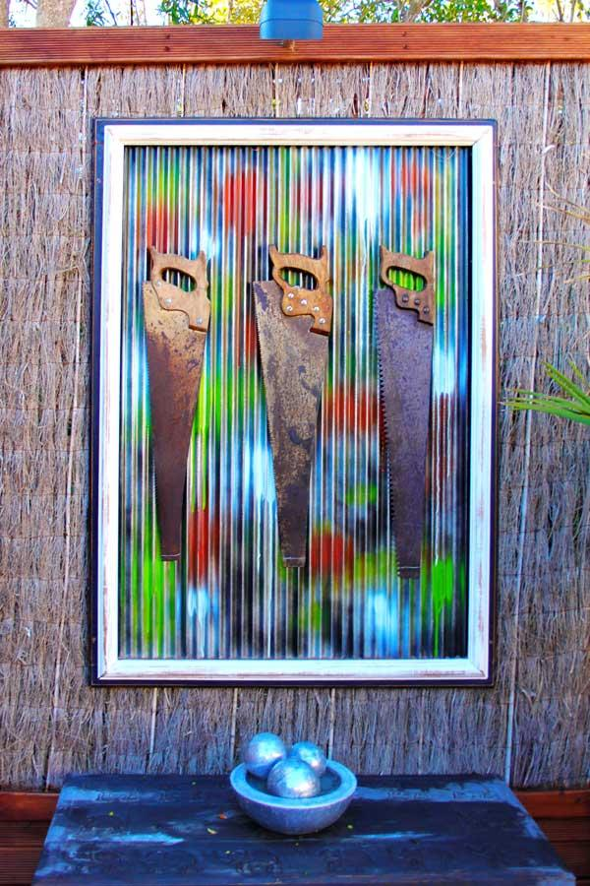

**Rick Rubens**

Rick Rubens is specialized in creating one-off statement pieces of furniture and wall art. He mainly uses reclaimed materials. He professionally crafts to designer standards, Rick’s selection of high quality pieces are specifically created for individuals who appreciate art and unique style.

When he thinks of artists, he thinks of painters, sculptors and people who have studied art. He has never studied it, but has always being creating it. “I never considered myself in that field, I saw myself purely as someone who does up old furniture,” says Rick Rubens.

After a few years he was persuaded by quite a few people that what he was doing was an art form, and he should market myself as an artist. That was the furthest thing from his mind that he was creating art. He still feels a degree uncomfortable with being called an artist. People say it doesn’t matter whether you have studied it, if you create art you are an artist.

He rarely draws his works first, he lets the materials available dictate to a certain extent what he’ll do. He works from his mind’s eye for all of his work. The final outcome remains fluid throughout the process, to adapt to the challenges faced when using reclaimed materials and the inspirations that come along the way.

People often ask him where his inspiration comes from and are often surprised to hear that he doesn’t actively look for inspiration. He is not saying that he doesn’t look at what is being created by others, but if it’s been done he tries to avoid doing similar work.

He believes in sustainability and uses reclaimed materials and old furniture. What he loves the most about using the old furniture and reclaimed material is the transformation from something unloved and sometimes destined for landfill. Wood is his favourite material. A plain old piece of wood or an old bed frame can be made into something quite special. It can take on so many different appearances, has so many uses, can be easily recycled and given a brand-new life.

He is from the UK, but has been in New Zealand for years now and really enjoys it here. He didn’t decide to upcycle furniture, it came about. When he started upcycling furniture, it was a fairly new expression, where you take something and make it better than it was originally. By making it either of better value or better aesthetic appeal. He loves what he does, but doing it commercially does take some of the enjoyment out of it.

**“People say it doesn’t matter whether you have studied it, if you create art you are an artist.”**

Rick first started selling his work on Trade Me, but now sells it from his website http://www.rickrubens.co.nz and at some galleries. He is hoping to find places to sell his work in Auckland and is exploring the possibility of selling his work in the UK, where there is a mature market place for his type of work.

Rick Rubens has excellent attention to detail, his artworks are beautiful and extremely well made. Each piece he makes are unique one-off pieces, made with exceptional craftsmanship and exceed his client’s expectations.

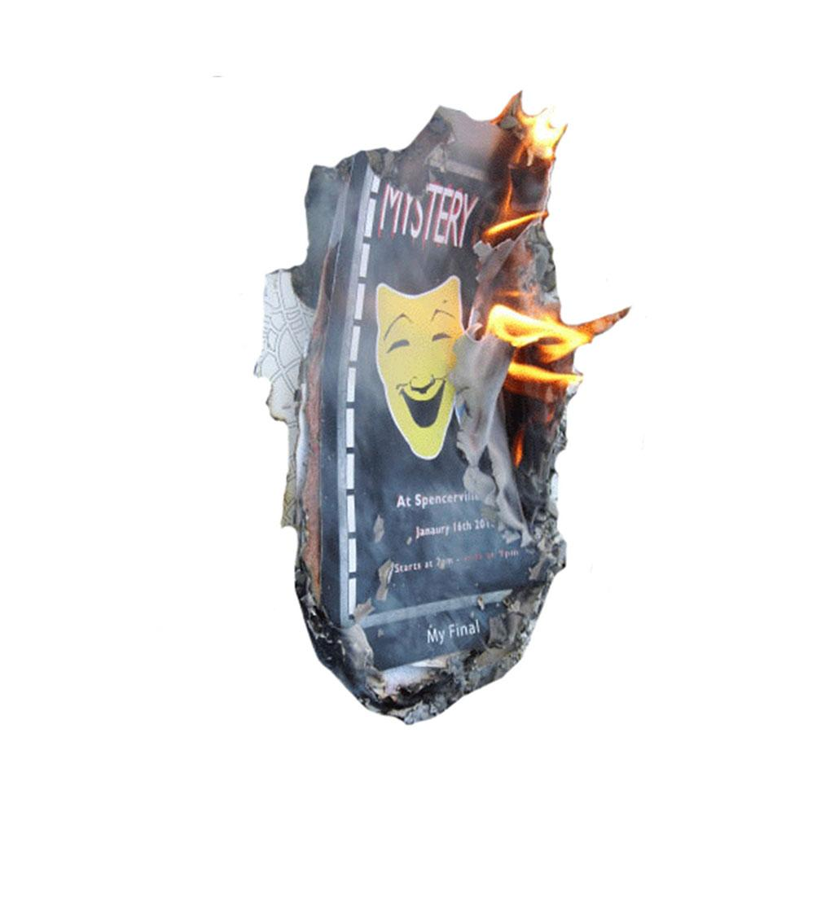

THE DEATH OF ART

***“Art is life, and I cannot survive without it. It helps me to get through hard times and it gives me an outlet for my expression.”***

***Sarah Van Eeden investigates what’s happening to the art curriculum.***

***Art is under attack. It is being pulled from the curriculum of schools and Universities, nationally and internationally. In the UK they are trying to funnel out art subjects in schools, and replace them with ‘core’ subjects. In US art is not respected. In New Zealand Art is changing.***

The English Baccalaureate (EBacc) qualification was introduced in 2011 in the UK. Students are required to gain good GCSEs in two sciences, English and Maths, a language and either History or Geography. This could push schools away from offering arts subjects, because they feel that it would overload the students. The Cultural Learning Alliance were concerned that it would be the death of art subjects.

The Warwick Commission on the Future of Cultural Values, found that between 2003 and 2013 there was a 50% drop in GCSE entries for design and technology, 23% for drama and 25% for other craft-related subjects. The Cultural Learning Alliance’s concerns were coming true. Students were becoming overloaded and rejecting art subjects.

Danny Gregory, an American blogger says that some states in the US think that art subjects shouldn’t be taught in schools, because “Art” is not respected in America. It’s seen a silliness, a luxury, a way to keep kids busy with crayons and paper. According to him “Art” is an upper class luxury that hard-nosed bureaucrats know they can remove without punishment, so they do. Bureaucrats make Maths and Science the priority to fill the ranks of future bankers, accountants and lawyers.

He thinks that art is important, because it helps to solve the world’s problems. We need to make sure that kids in today’s society realize just how much creative potential they have, and have the tools to help them use that creativity. We need creative people in today’s society. “Creativity is not a ghetto” says Danny Gregory “not a clique, not something to be exercised alone in a garret. It’s also not a freak show of self-indulgent divas and losers.”

**“It’s also not a freak show of self-indulgent divas and losers.”**

New Zealanders are artistic people, who believe that being involved in the arts makes communities stronger and people’s lives better. “Nine out of ten adult New Zealanders (88%) agree the arts are good for them and eight out of ten (82%) agree that the arts help to improve New Zealand society.” says Creative New Zealand.

Art is very important in New Zealand. The creative industries are struggling to get enough people for all the creative jobs they have. Many companies are bringing people from overseas.

Take for example WETA Workshop. “Weta Workshop bring not only world class artistic and technical talent to what they do, they also bring a spirit and a passion which is invigorating for the filmmaker.” says Canadian filmmaker James Cameron. But with their growing international reputation WETA has had to apply for over 400 work visas in just one year to fill its vacancies.

Art is changing in New Zealand and this is why the industry struggle to get all the people needed for those jobs. It is hard to get the qualifications and experience required. It’s either unaffordable for people or they don’t meet the entire requirements, or are pressured into going for a different career.

Bruce McMillan worked in professional art studios for about 15 years, but became tired of that. So he moved out to the country and had a little art business that he ran from home, while working as a shearer. He would shear sheep in the season, then make art in the off season. When he was 38, he decided he would love to go back to art school, so he did. Then it was suggested to him that art teaching could be a good career for him.

Early in his life he wore hearing aids, so he didn’t hear very well. But he had some operations that fixed that, so he thought “here is my opportunity”. He went to art school and training college and got a job at RHS first teaching job. He believes art is a very important part of the education of a well rounded person. pointing out that “Humans drew on cave walls before they had language”.

Yes, Art schools struggle to get students, but art is changing not dying. The discipline of design and the applied arts as taught in Polytechs are still strong. We live in a visual world and learning to understand the power of images is important. It teaches students to tell stories about their world. On a broad scale making art is part of what makes us human.

Art is a weapon, entertainment, an expression, a way to explore new ideas and expand your creativity. It’s speaking up against the wrongs, and the rights in the world. It gives us the freedom to be who we are and be unique.